To: 2024 NHSMTC adult observer and attendees
From: Delaware 2024 Host Committee
Date: February 10, 2024
Re: 2024 National High School Mock Trial Championship—TABROOM REGISTRATION MEMO FOR OBSERVERS

PLEASE READ THIS MEMO CAREFULLY AND COMPLETELY.
IF YOU DO NOT HAVE A TABROOM ACCOUNT, PLEASE START AT STEP 1.
IF YOU ALREADY HAVE A TABROOM ACCOUNT, PLEASE PROCEED TO STEP 2.
THERE ARE THREE STEPS TOTAL.

Registering as an adult observer or attendee only allows attendance at the competition rounds themselves, it does not provide access to any event. Tickets to the awards gala may be purchased from the “Store” at the competition website beginning April 1, 2024.
STEP 1: Create an account on https://www.tabroom.com
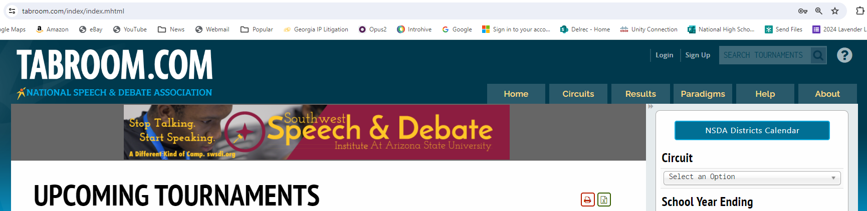
- In the top right corner of the Tabroom webpage, click “Sign Up.”

- Fill out the information under the “Non-NSDA Members” heading, and then click “Create Account,” making sure to remember or otherwise document the email and password you chose. NOTE: You must include responses for a phone number and cell provider in order to complete subsequent steps.
- Once you have submitted the form, you will need to confirm your Tabroom account. You will receive an email with a verification code to enter in order to verify your account.

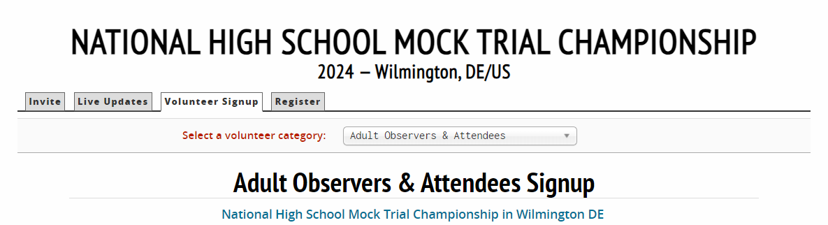
STEP 2: Sign up for the 2024 National High School Mock Trial Championship
- To register, either click here or go to https://nhsmtc.tabroom.com
- Make sure you are on the “Volunteer Signup” tab. (See screenshot to the right)
- Under “Select a volunteer category” choose “Adult Observers & Attendees”
- If you are not yet logged in to Tabroom.com, you must log in. If you did not complete step 1, above, you must do so.
- Enter your current professional affiliations.
- For “School Conflicts” you should list the name of the school / institution that you are observing.
  - Note that this is not a “conflict”—it is so that we can correctly pair you with your team.
  - We know this is not ideal, but we are using a system that was originally developed for speech and debate and that has not been fully adapted to us.
- Click the “Register to Judge” button (note, this button only activates when all required fields are completed)
  - Again, we are using a system that was originally developed for speech and debate. We promise we are not going to make you judge.

STEP 3: Select your “Conflicts & Affiliations”
- Once you click “Register to Judge” you will be taken to the “Conflicts & Affiliations” and Confirmation page.
- From the drop-down menu, choose your state/territory of the team you are attending to observe / be a supporter for.
  - Again, this is not a “conflict” but a secondary check (in case you don’t fill out the “School Conflict”) to make sure that you are associated with the correct team.
  - NOTE: If you choose an option in error, click the red trashcan icon by the state to remove it.
