To: 2024 Delaware High School Mock Trial Coaches
From: Delaware 2024 Host Committee
Date: February 10, 2024
Re: 2024 National High School Mock Trial Championship—TABROOM REGISTRATION MEMO

Dear Teacher and Attorney Coaches,
As we did last year, we will run the tournament through Tabroom.com and are expanding our use of tabroom to simplify registration for the competition. This memo provides full guidelines for how to create a tabroom account and register your teams in tabroom.
PLEASE READ THIS MEMO CAREFULLY AND COMPLETELY.
If your institution competed in the 2023 NHSMTC in Little Rock, you should begin at step 4. Otherwise, begin at step 1.
YOU MUST REGISTER IN TABROOM BY APRIL 17, 2024.
YOU MUST SUBMIT ANY OUTSTANDING PAYMENTS BY APRIL 26, 2024.
YOU MAY MODIFY YOUR ONLINE ROSTERS UNTIL MIDNIGHT ON MAY 1, 2024.
STEP 1: Create an account on https://www.tabroom.com
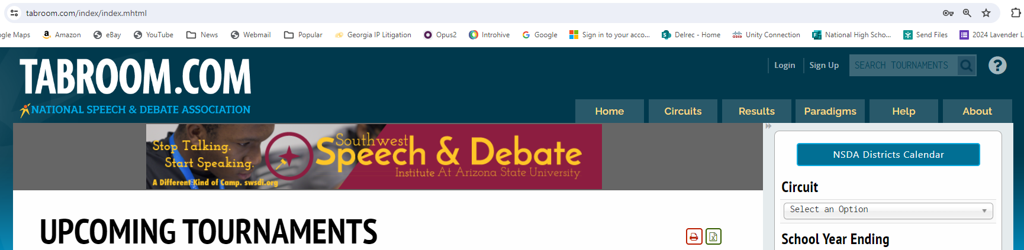
- In the top right corner of the Tabroom webpage, click “Sign Up.”

- Fill out the inforamtion under the “Non-NSDA Members” heading, and then click “Create Account,” making sure to remember or otherwise document the email and password you chose.
- Once you have submitted the form, you will need to confirm your Tabroom account. You will receive an email with a verification code to enter in order to verify your account.
- Each coach associated with a school must complete this step and must register for Tabroom.

STEP 2: Create your school
- Once you are logged into Tabroom (after verifying your account, click on “Create your Institution.”
- Complete the form and click “Save School Info.” You do not have to provide a full mailing address. The two required fields are school name and state.
- NOTE: If your school also has a speech and debated program, it may ask you to confirm that you mean to create a new program instead of gaining access to the existing school account. That’s in place so that if a debate coach leaves, we can give the new coach access to the program history instead of them creating a new one. However, for your purposes AND IF YOUR INSITUTION DID NOT COMPETE AT NATIONALS IN LITTLE ROCK, scroll to the bottom of the page and select “You confirm this is not a duplicate program” and hit “Save School.
- Once you have created your institution, when you log in, you will be taken to your school’s page in Tabroom. From here, you can complete the necessary registrations for your team using the instructions that follow. When you login to Tabroom, you should be taken to your school’s page by default and Tabroom defaults to the view in the “Tournaments” tab.
- We strongly encourage the coaches for each institution (rather than the state coordinators) to create and “own” the institution.

STEP 3: Join the National High School Mock Trial Circuit
- The first time you log in to Tabroom.com after creating your institution, you will see a page that looks like the below:
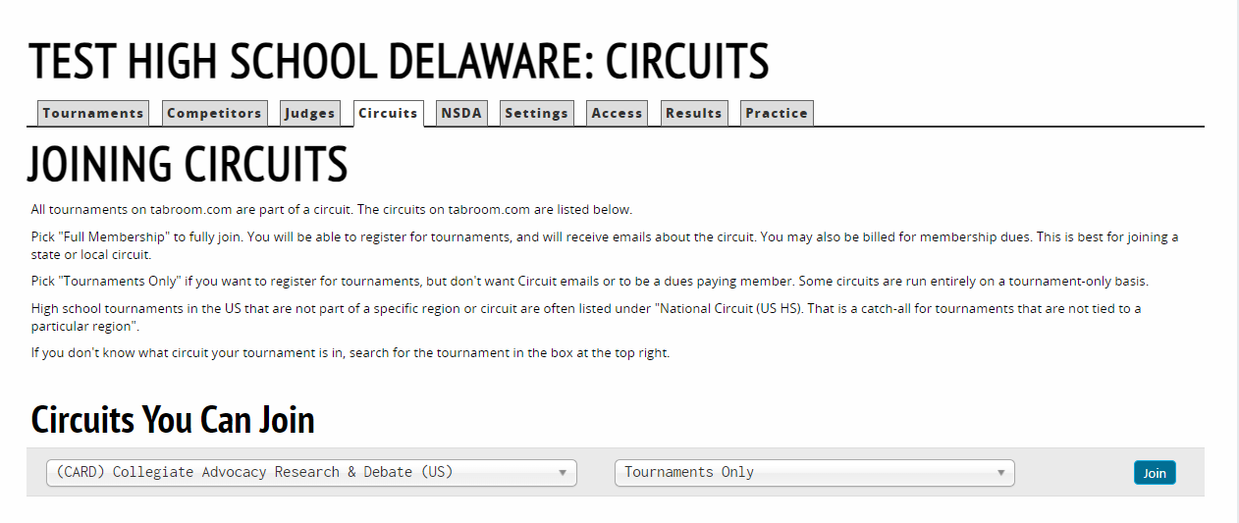
- Tournaments in Tabroom are organized by “circuit.” This helps you to see only those tournaments that are relevant to your school. Delaware’s state competition is in the National Mock Trial (US) circuit.
- Using the drop down menu on the left, search for or scroll to “National Mock Trial (US)” and click “Join”

STEP 4: Make sure that all coaches are associated with your institution
- In order for your coaches to have access to your institution (and to register so we know they are coming to the Championship), it is imperative that ALL coaches register for a Tabroom.com account (STEP 1), and that the owner of your institution (i.e., the person that created the institution in Tabroom), associate the coaches with the team.
- To associate the coaches with the team, go to the “Access” tab (shown below) and add them using the email address they used to sign up in Tabroom.
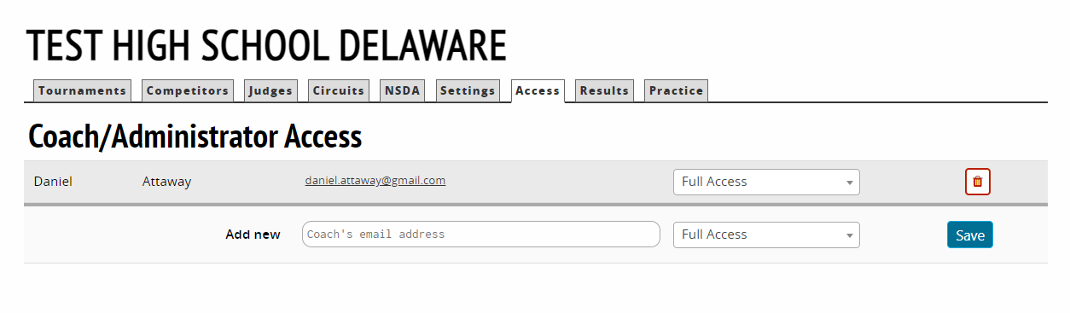
- To reiterate, EACH COACH ASSOCIATED WITH YOUR TEAM MUST MAKE A TABROOM ACCOUNT AND YOU MUST ASSOCIATE THE COACH WITH YOUR TABROOM INSTITUTION TO REGISTER THE COACHES WHO WILL BE ATTENDING THE COMPETITION.

STEP 5: Add your students to your school
- On the main screen for your institution, select “Competitors”
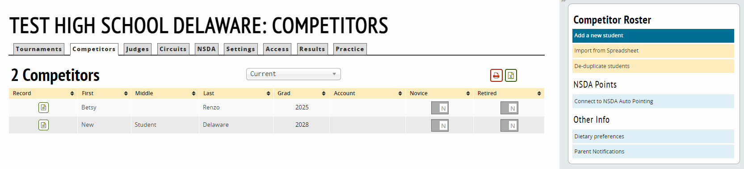
- Then you will select “Add a new student” under the Competitor Roster tab at the far right (shown below)
- For each student, please enter at least the student’s first and last name and graduation year.
- If your student has a hard to pronounce name, we would appreciate you completing the Phonetic Guide.
- Once you have completed the information for the student, please click “Save Student Info.”
- To add the next student, click “Add another student” on the right hand side of the screen. Repeat until ALL students from your school associated with the competition have been added.
- When complete, click “Return to student roster.” Your screen should now look like the below:
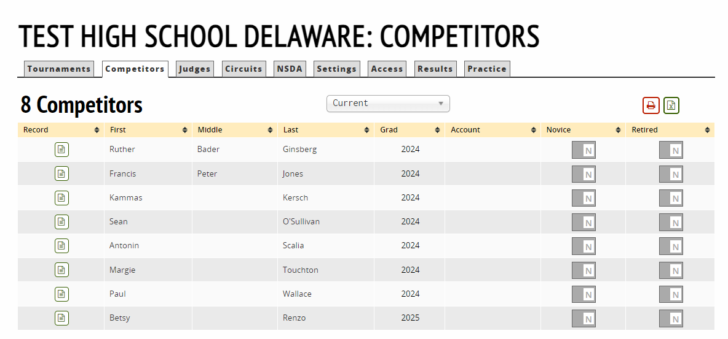

Step 6: Register for the NHSMTC
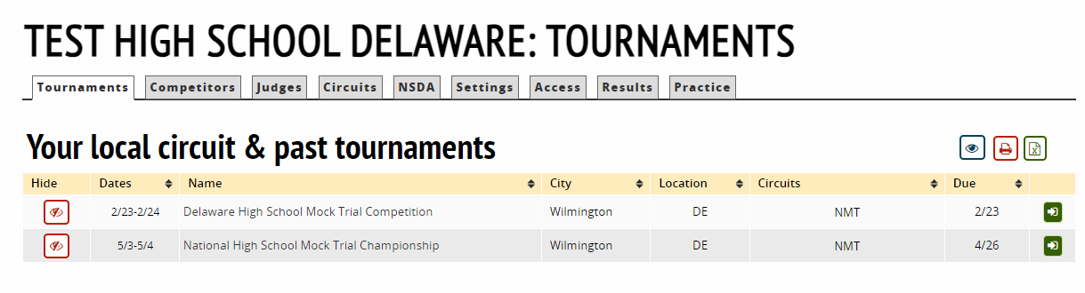
- Once you have joined the Circuit, the “Tournament” tab for your school will look similar to the image to the right.
- Click on the green arrow on the right of “National High School Mock Trial Competition” to go to the compeition home page.
- This is what the competition home page will look like:

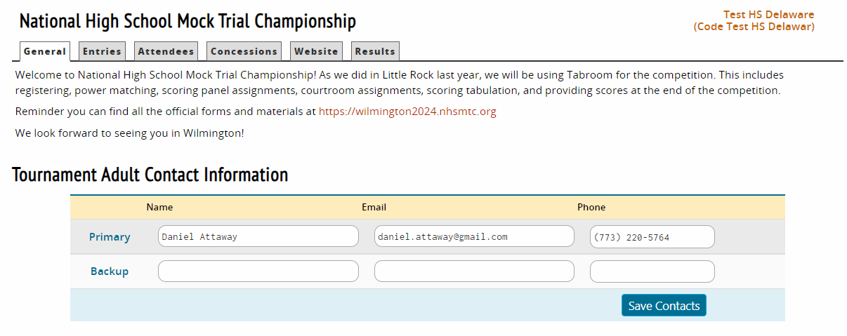
- If you accessed the site from nhsmtc.tabroom.com, click the “Register” tab.
- The Register tab is where you will complete registration for your school for the mock trial team(s), courtroom artist, and courtroom journalist competitions.
- First, please add a backup adult contact for the tournament. After entering the information, click “Save Contacts.”
- Next, please choose your state and click Save.

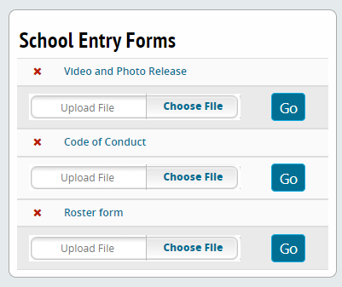
STEP 7: Download the required forms
- On the right side of the screen you will see a box that is titled “School Entry Forms.” These forms are the required forms for the competition. Completed versions of the form(s) (except for the roster form) must be uploaded prior to the start of the competition. The roster form must be completed and you must bring 40 copies of the roster with you to the competition.
- You can download each form by clicking on the name.

Step 8: Add your teams and competitors.
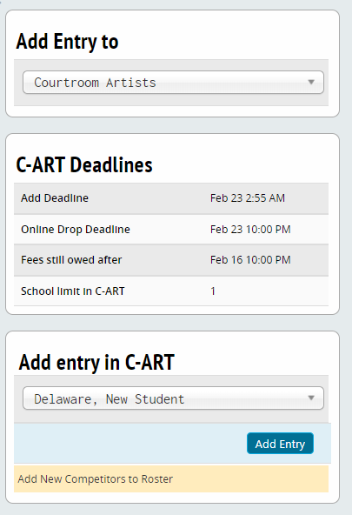
- On the competition home page for your school, click on the “Entries” tab
- On the right side of the screen, there will be a box that says “Add Entry To.” Click on this to open the drop down menu.
  - Each team is allowed one entry per school for the courtroom artist, courtroom journalist, and mock trial team
- For example, selecting the Courtroom Artist will cause the screen to look like the image to the right.
- Select the student from your roster from the drop-down menu and click “Add Entry.” If the student is not on your roster, select “Add New Competitors to Roster.”
- Repeat for the Courtroom Journalist competition, if applicable.
- When you select Trial team, you will select “Add entry in Team” which will bring up the following screen:
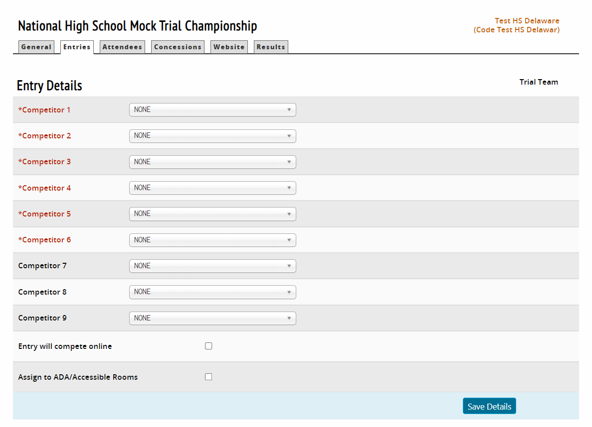
- Note that you must enter at least six competitors.
- Select each competitor for the team.
- If a member of your team (student, coach, or observer) requires an ADA accessible courtroom, please click the box for “Assign to ADA/Accessible Rooms.”
- Click “Save Details”
- Click on “Entries” to return to the “Entries” screen. Once you have completed the entries, your “Entries” tab should look something like the below (assuming you have registered a mock trial team, an artist, and a journalist):
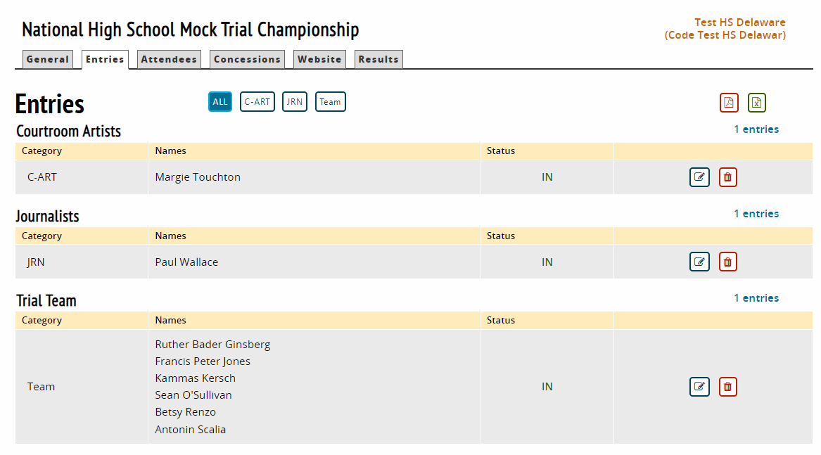
- Note that you must also register any students who are traveling with you but are not official team members into the Non-Competing Student Attendees” event.
Step 8: Confirm Awards tickets, any dietary restrictions, and Student All-Access passes
- Next, you will need to confirm the number of tickets for the awards ceremony, enter any dietary restrictions for the coaches or students, and order additional “all access” passes for non-official team members.
- To do this, click on the “Tickets and Misc.” tab (as shown below):
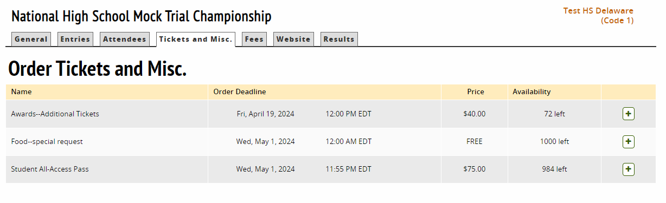
- For All Access Passes, select the number of non-official team members (i.e., students beyond the 9 allowed members for a trial team, 1 member for courtroom artist, and 1 member for courtroom journalist) that are traveling with you. All Access Passes allow the students to attend all events as if they are an official team member.
  - NOTE: All Access Passes are available to students only.
  - NOTE: You must order All Access Passes here AND register those students in the Non-Competing Student Attendees Event
- For the Awards—Additional Tickets, you only need to order additional tickets if one of the following applies:
  - You have more than three (3) coaches, or
  - You have unofficial team members traveling with you and who did not purchase All Access Passes, or
  - YOU DO NOT NEED TO ORDER TICKETS FOR OBSERVERS (although you can)—observers may buy tickets for the awards celebration in the “Store” tab at https://wilmington2024.nhsmtc.org beginning April 1, 2024.
- For the Accommodation?—please enter a 1 if any of your students or coaches may need accommodation and we will contact you separately. Please also see Rule of Competition 1.5 regarding accommodations.
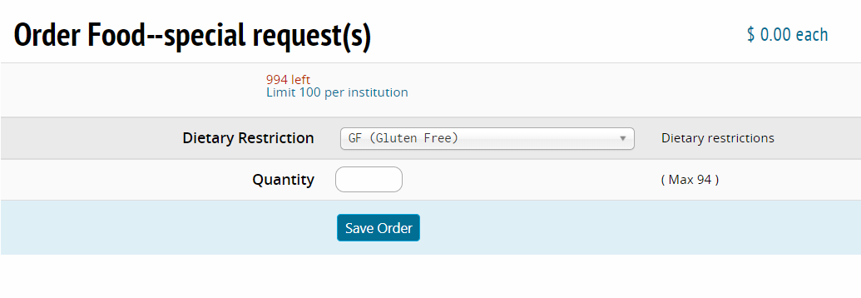
- When you click on the Food-special request, it will bring up a screen that will let you select the dietary restriction (gluten free, dairy free, vegetarian, kosher, nut allergy, or other) and enter a quantity. You will need to enter the total number for each type separately. NOTE: If you enter “Other,” please contact us separately to provide the restriction.
- Note that a running list of your orders will be shown on the right side of the screen, along with any costs associated with your orders.

Step 9: Print an invoice and PAY YOUR FEES
- If you need an invoice for the registration and other fees, you can access this under the “Fees” tab. This tab will show you a full accounting of all fees that you have incurred through registration.
- To print an invoice, click on the “Print Full Invoice” on the right side of the screen.
  - Note: if you need to exclude certain fees (for example, to make multiple invoices for different costs) you can do so on the right side by excluding information and then clicking print.
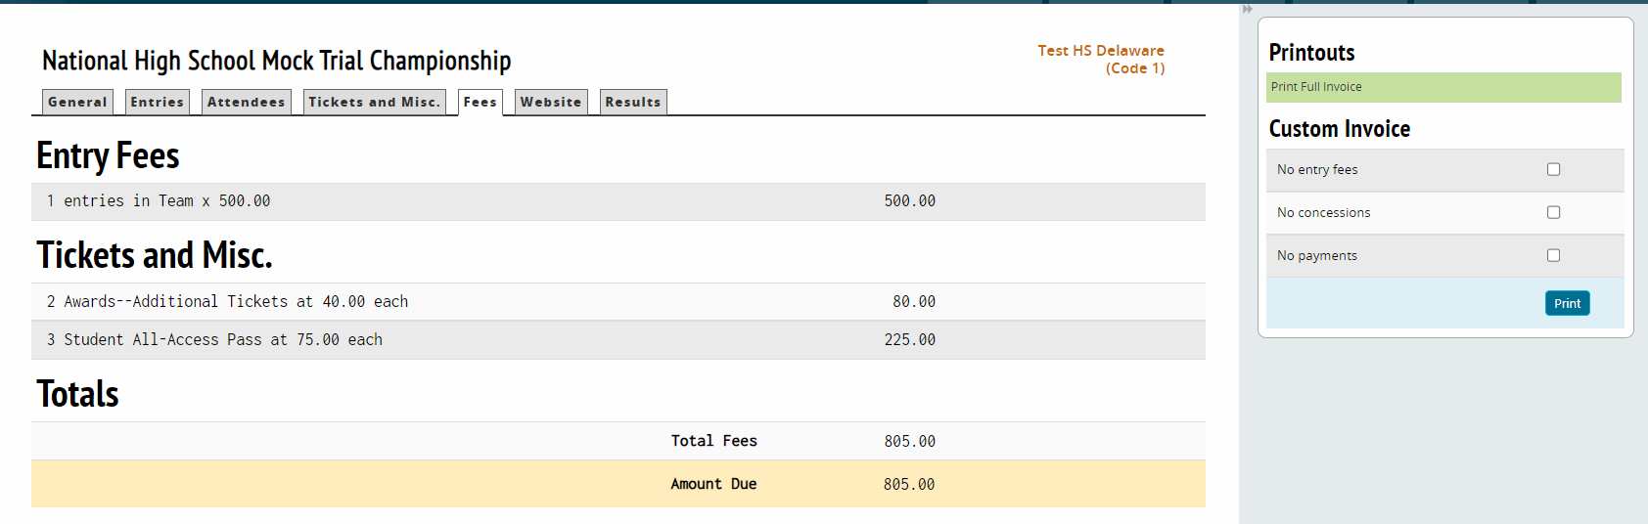
STEP 10: UPLOAD YOUR FORMS
- As a reminder, before the competition you must upload executed releases.

